**CONTENT**

|  |  |  |
| --- | --- | --- |
| **S.No.** | **CONTENT** | **PAGE No.** |
| 1. | Abstract | 2 |
| 2. | Project Overview | 3 |
| 3. | System Design | 4 |
| 4. | System Flowchart | 5 |
| 5. | Input Design | 8 |
| 6. | Output Design | 8 |
| 7. | Menu Level Description | 9 |
| 8. | Process Specification | 10 |
| 9. | Screen Layouts | 11 |
| 10. | Conclusion | 13 |
| 11. | Bibliography | 14 |

**ABSTRACT**

# The Employee Leave Management System is a web-based application developed to streamline the process of applying, approving, and managing employee leave requests within an organization. The system replaces traditional paper-based methods with a digitized, centralized platform, allowing for greater transparency, accuracy, and efficiency in handling leave-related workflows.

# Designed using modern web technologies such as HTML, CSS, and JavaScript, this system features a user-friendly interface that allows employees to submit leave requests by entering relevant details such as name, department, leave type, leave duration, and reason for leave. Once submitted, the leave application is visible to the manager or administrator through a real-time dashboard, where it can be reviewed and either approved or rejected.

# The system supports automated status updates, where approved leaves are immediately marked and recorded, while rejected leaves are flagged appropriately. It provides clear visual feedback to both the employee and the manager at each stage of the process, thereby enhancing user engagement and decision-making.

# In addition to simplifying leave approval, the system reduces administrative overhead, eliminates the risk of manual errors, and ensures that records are stored securely and are easily retrievable. Its lightweight architecture ensures quick deployment and ease of maintenance, making it ideal for small to mid-sized organizations looking to digitize their HR processes.

# Overall, the Employee Leave Management System is a practical, scalable, and reliable solution that empowers both employees and administrators to manage leave applications more effectively, ensuring smooth operation and better organizational productivity.

# INTRODUCTION

### PROJECT OVERVIEW

The project entitled **Employee Leave Management System** is a responsive and user-focused web application developed to streamline and automate the process of managing employee leave requests within an organization. Designed to eliminate the inefficiencies of traditional paper-based workflows, this system enables employees to apply for leave through a structured form that captures essential details such as name, department, leave type, duration, and reason.

Once submitted, the application is instantly reflected in the administrator’s dashboard, allowing for prompt review and status updates. The system incorporates role-based access control, where employees are limited to submitting and viewing the status of their applications, while administrators are authorized to approve, reject, and update leave records. Built using HTML, CSS, and JavaScript, the platform is lightweight, cross-platform compatible, and optimized for clarity and usability.

It features a logical, step-by-step workflow that enhances administrative responsiveness and reduces processing delays. By digitizing the entire leave management lifecycle, the system ensures improved record accuracy, minimizes manual intervention, and fosters transparent communication between employees and management. Its modular architecture also lays the groundwork for future enhancements, such as reporting, analytics, and integration with broader human resource systems, making it a scalable and efficient solution for modern organizational needs.

The Employee Leave Management System is not only a tool for handling routine administrative tasks but also a foundation for building more comprehensive human resource management capabilities. Its architecture supports easy integration with advanced modules such as employee attendance tracking, payroll systems, departmental performance metrics, and policy compliance auditing.

## 2. SYSTEM DESIGN

### 2.1 INTRODUCTION

System design is the process of defining the architecture, components, modules, interfaces, and data structures that collectively fulfill the specified requirements of a software system. It represents the transition from understanding what a system needs to do (as identified in system analysis) to figuring out how to achieve those requirements in a structured and efficient manner. While system analysis answers the “what is” question, system design addresses the “how to” aspect of building or improving a system.

This phase plays a critical role in shaping the success of the project. It involves not only outlining technical solutions but also ensuring that these solutions align with the operational and strategic goals of the organization. System design takes the recommendations from the feasibility study and converts them into a comprehensive blueprint for development, laying the groundwork for the implementation phase.

Before diving into system design, careful planning is essential. It is important to conduct a thorough analysis of the existing system—understanding its limitations, inefficiencies, and pain points—to identify how the new or upgraded system can bring about measurable improvements. This involves evaluating how the integration of computing technologies can enhance overall performance, reduce manual effort, and streamline workflows.

The significance of system design lies in its impact on quality. Design is where the foundation for high-quality software is built. A well-crafted design not only meets user requirements but also ensures maintainability, scalability, security, and efficiency of the system. It acts as a communication bridge between the end-users and the developers by transforming user-oriented documentation into technical specifications that can be interpreted and implemented by programmers, database administrators, and system architects.

Moreover, system design is both a technical and creative endeavor. It demands a blend of analytical thinking, problem-solving, and innovation to architect a solution that is technically feasible, economically viable, and user-friendly. It also includes considering user interfaces, data flows, control logic, and hardware-software integration, all of which contribute to a system that is robust, adaptable, and efficient in meeting its intended purpose.

In summary, system design is not just a step in the development cycle—it is the foundation of a successful and sustainable software product. A strong design ensures that the final system is reliable, efficient, and tailored to meet user expectations and institutional objectives.

### 2.2 SYSTEM FLOWCHART

The classical system flowchart approach to describing and documenting a system will be presented. These system flowcharts are also used in the structured approach that is, form the general to detailed, of the system development life cycle.

Because they have been used to describe system for many years, they are still common in many businesses.

**Basic Flow chart Symbols:**

Process

Input - Output

 Connector

Off page Connector

Data Flow

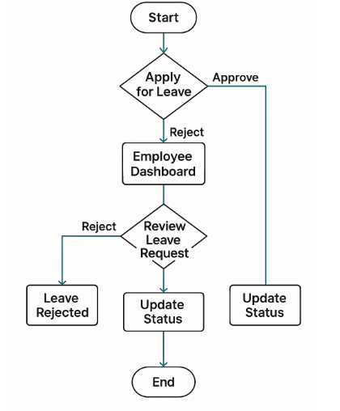

**Fig 2.1 Employee Leave Management System Flow Chart**

**Fig 2.1** The operational flow of the Employee Leave Management System is centered around streamlined form submission, secure validation, and responsive status updates. The workflow begins when an employee accesses the system and is prompted to enter the required leave details through a structured form. This includes essential fields such as name, department, leave type, from and to dates, and reason for leave.

The first decision point in the flow involves validating the input data. If any mandatory fields are left blank or filled incorrectly, the system halts further processing and prompts the user to correct the information, ensuring data accuracy and completeness. Once the validation is successful, the leave request is submitted and stored, and the user receives an on-screen confirmation indicating successful application submission.

After submission, the system automatically updates the administrator dashboard, where all pending leave requests are listed for review. At this stage, the admin can either approve or reject each request based on organizational leave policies and employee eligibility. This decision is the next key branch in the flow. If approved, the status of the leave request is updated to “Approved” and recorded in the system; if rejected, it is marked as “Rejected,” and the employee is notified accordingly.

The entire flow is designed to support clear communication between employee and admin, with real-time feedback and updates. Each action is backed by user confirmation messages, reducing ambiguity and increasing transparency. The flow concludes once the leave status is finalized and displayed back to the employee, completing the leave application cycle.

This structured process ensures accuracy, traceability, and a clear audit trail for all leave requests. It not only simplifies leave administration but also enhances organizational accountability and efficiency in managing employee time-off requests.

### 2.3 INPUT DESIGN

**1. Employee (Leave Applicant):**

* **Leave Application Form:**
  + **Name:** Full name of the employee (text input).
  + **Department:** Department to which the employee belongs (dropdown/text).
  + **Leave Type:** Type of leave (e.g., Casual, Sick, Paid) (dropdown).
  + **From Date:** Start date of the leave (date picker).
  + **To Date:** End date of the leave (date picker).
  + **Reason:** Justification or remarks for the leave (text area input).
* **Validation:**
  + All fields are required.
  + Date fields must follow logical sequence (From Date ≤ To Date).
  + Leave type selection is mandatory.

### 2.4 OUTPUT DESIGN

**1. Employee:**

* **Submission Status:**
  + On successful submission, popup message: “Leave request submitted successfully.”
  + Redirection or update to a confirmation section displaying applied leave details.
* **Leave Status View:**
  + After admin action, status updates to:
    - **Approved**
    - **Rejected**
  + Displayed beside corresponding application entry.

**2. Administrator:**

* **Leave Dashboard:**
  + Real-time list of all submitted leave applications.
  + Each entry shows:
    - Employee Name
    - Department
    - Leave Type
    - From and To Dates
    - Reason for Leave
    - Current Status (Pending / Approved / Rejected)
* **Admin Action Panel:**
  + Buttons to **Approve** or **Reject** each application.
  + On action, status is updated instantly.
* **Error Feedback:**
  + If required fields are missing during employee submission, an error message prompts correction.
  + Invalid or incomplete actions are prevented by form validation.

## 3. SYSTEM DEVELOPMENT

### 3.1 MENU LEVEL DESCRIPTION

###### The Menu Level Description for the Employee Leave Management System is organized as follows:

###### 1. Login Menu:

###### Homepage:

###### The main landing page for employees and administrators to enter login credentials.

###### Fields: Username and Password.

###### Authentication Result:

###### On successful login, redirects the user to the respective dashboard.

###### On login failure, an error popup is displayed indicating incorrect credentials.

###### 2. Leave Application Menu (Em

###### ployee View):

###### Employee Dashboard:

###### Allows employees to fill and submit the Leave Application Form.

###### Displays all previously submitted applications along with their current status.

###### Leave Application Form:

###### Fields include:

###### Name

###### Department

###### Leave Type

###### From Date

###### To Date

###### Reason for Leave

###### A submit button to trigger validation and submission.

###### 3. Leave Review Menu (Ad

###### min View):

###### Admin Dashboard:

###### Displays a list of all leave applications submitted by employees.

###### Each application shows:

###### Employee Name

###### Department

###### Leave Type

###### Dates

###### Reason

###### Status (Pending, Approved, Rejected)

###### Leave Approval Panel:

###### Options to Approve or Reject each application.

###### Status is updated dynamically upon selection.

### 3.2 PROCESS SPECIFICATION

**Process specification** is a systematic approach used to define, analyze, and document the logical steps involved in converting user input into system output. In the **Employee Leave Management System**, the process specification outlines how leave requests are handled, validated, reviewed, and updated. This helps ensure consistent functionality, operational clarity, and scalability of the application.

**1. Leave Application Submission:**

**Step 1:**  
Employees fill out the leave application form with required fields:

* Name
* Department
* Leave Type
* From Date
* To Date
* Reason

**Step 2:**  
The system performs client-side validation to check for:

* Completion of all fields
* Logical date sequence (From Date ≤ To Date)

**Step 3:**  
Upon successful validation, the form data is submitted and stored locally or in the backend (if applicable), and a success popup is shown to the user.

**2. Leave Application Display (Admin View):**

**Step 1:**  
Upon login, the administrator accesses the **Leave Review Dashboard**.

**Step 2:**  
The system retrieves and displays all submitted leave applications in a tabular or card-based format.

**Step 3:**  
Each record includes:

* Employee Name
* Department
* Leave Type
* Leave Duration
* Reason
* Current Status (Pending / Approved / Rejected)

**3. Leave Approval or Rejection:**

**Step 1:**  
The administrator selects either the **Approve** or **Reject** button for each leave request.

**Step 2:**  
The system updates the status of the selected application and reflects the change on both admin and employee views.

**Step 3:**  
A confirmation popup is displayed after each action.

**4. Access Control:**

**Step 1:**  
Only logged-in users can submit or view leave applications.

**Step 2:**  
Employees can only access their own submissions and status, while administrators can view and manage all applications.

**5. System Maintenance and Scalability:**

**Step 1:**  
The system allows for the following future updates:

* Addition of new leave types
* Extension of application duration limits

**Step 2:**  
Future enhancements may include:

* Admin panel for managing employee accounts
* Leave history analytics and reporting
* Integration with HR and payroll systems
* Email or SMS notifications for approval/rejection

**4. SYSTEM TESTING**

**4.1 SCRREEN LAYOUTS**

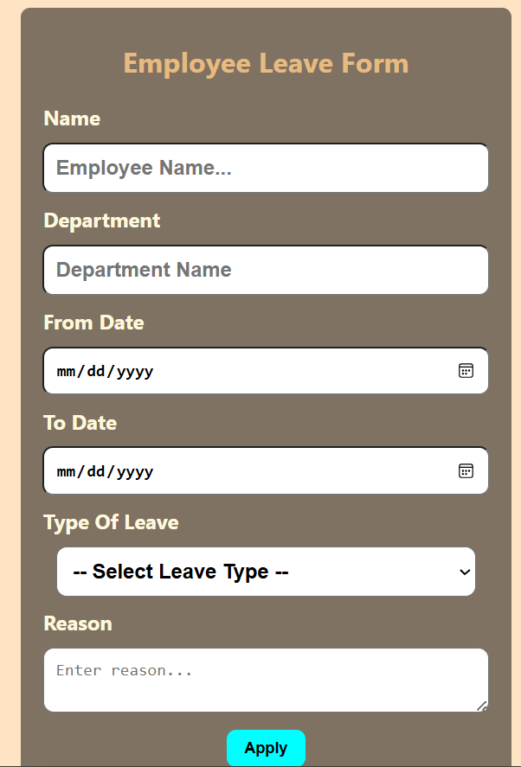

Employee Login Page & Leave Application Form

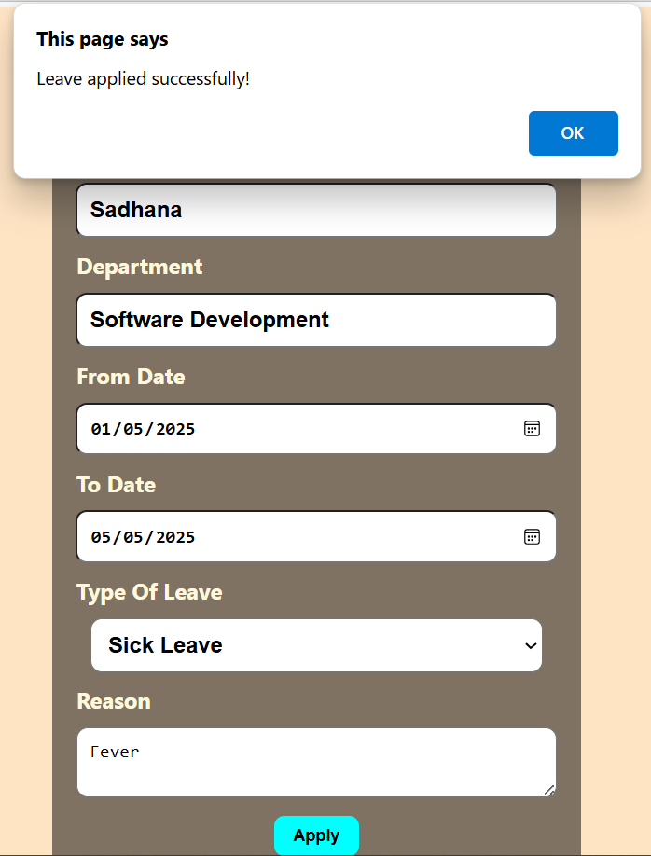

Leave Submission Success Popup

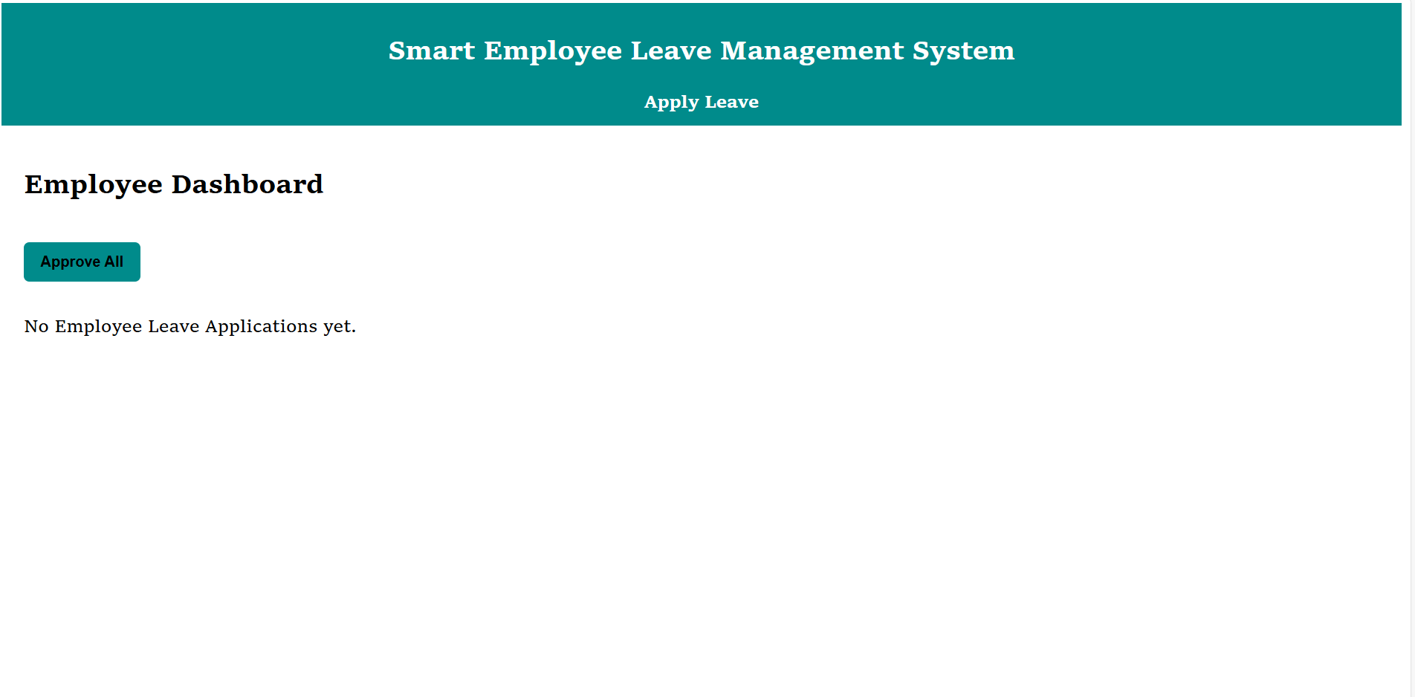

#### Admin Leave Dashboard

#### 

#### Leave Status Display Employee

#### 

#### Leave Approval Success Page

## 5. CONCLUSION

The Employee Leave Management System is a robust and scalable web-based application that addresses a key administrative function within organizations—managing employee leave efficiently and transparently. It replaces the error-prone and time-consuming paper-based processes with an automated system that facilitates faster decision-making, enhances communication, and ensures accurate recordkeeping.

By implementing a structured leave application process, the system empowers employees to independently manage their leave requests, while providing administrators with a centralized dashboard to view, assess, and respond to those requests efficiently. The integration of validation checks ensures data integrity, while role-based access guarantees that system usage is secure and compliant with organizational policies.

The application not only enhances day-to-day operational efficiency but also contributes to building a more accountable and organized workplace culture. Employees benefit from transparency and timely updates on their application statuses, while HR or administrative teams experience a reduction in workload and better clarity in resource planning.

From a technical standpoint, the system is lightweight, responsive, and modular, making it suitable for deployment in a wide variety of organizational contexts—from small businesses to larger enterprises. The flexibility in its architecture allows for seamless scaling and integration with advanced modules, such as real-time calendars, departmental leave quotas, email notifications, analytics dashboards, or even payroll systems.

Additionally, the system’s digital audit trail ensures historical leave data is always available, which is valuable during internal reviews, performance evaluations, or compliance reporting. With a growing emphasis on automation and data-driven decision-making in HR processes, the Employee Leave Management System aligns perfectly with the digital transformation goals of modern organizations.

## 6. BIBLIOGRAPHY

1. OpenAI: "GPT-3: Language Models for Text Generation." https://[www.openai.com](http://www.openai.com/)
2. GeeksforGeeks: "Computer Science Portal." [https://www.geeksforgeeks.org](https://www.geeksforgeeks.org/)
3. YouTube: “Various Tutorials and Educational Content." https://[www.youtube.com](http://www.youtube.com/)